Healthy Food and Nutrition
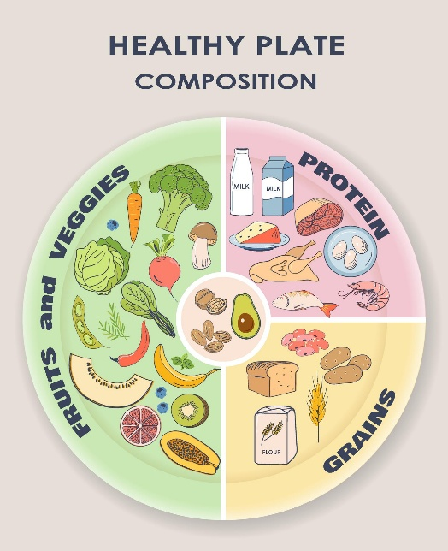
Healthy eating is essential for maintaining physical and mental well-being. A balanced diet provides the nutrients the body needs to function properly.
Fruits and vegetables are rich in vitamins, minerals, and antioxidants. Whole grains provide energy and dietary fiber, while proteins help build and repair body tissues.
Eating a variety of foods ensures that the body receives essential nutrients. Drinking sufficient water and reducing the consumption of processed foods also contributes to better health.
Regular healthy eating habits can reduce the risk of diseases such as diabetes, heart disease, and obesity.

